**Sorting of numbers in a sequence**

**Exp 3 (a) : Ascending Order**

**Aim :**

To write and execute an 8085 program to sort a set of numbers in ascending order.

**Apparatus Required:**

• 8085 Online Simulator (8085simulator.github.io or similar) • Test input data • Instruction set reference

**Algorithm (Ascending Order):**

1. Load count from memory into register C.

2. Subtract 1 from count and store in B (outer loop counter).

3. Outer loop (B times): Point HL to the first data. Copy C to D (inner loop counter). Inner loop (D times): Compare adjacent elements. If current > next, swap them. Decrement B and repeat.

4. End.

**Program:**

; --- Read 5 inputs from ports 01H–05H ---

IN 01H

STA 0000H

IN 02H

STA 0001H

IN 03H

STA 0002H

IN 04H

STA 0003H

IN 05H

STA 0004H

; --- Bubble Sort (on memory 0000H–0004H) ---

MVI C, 04H ; outer loop count = 4 passes

OUTER: LXI H, 0000H ; HL -> first element

MOV B, C ; inner loop counter

INNER: MOV A, M ; A = [HL]

INX H ; next element

CMP M ; compare A with [HL]

JC NOSWAP

JZ NOSWAP

; Swap

MOV D, M ; D = [HL]

MOV M, A ; [HL] = A

DCX H

MOV M, D ; [HL] = D

INX H ; back forward

NOSWAP: DCR B

JNZ INNER

DCR C

JNZ OUTER

; --- Output sorted numbers to ports 06H–0AH ---

LDA 0000H

OUT 06H

LDA 0001H

OUT 07H

LDA 0002H

OUT 08H

LDA 0003H

OUT 09H

LDA 0004H

OUT 0AH

HLT

**Output:**

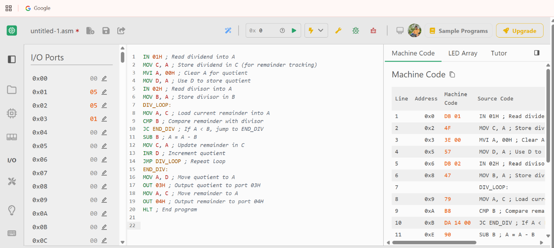

**Input Ports**:

● 01H → First number

● 02H → Second number

● 03H → Third number

● 04H → Fourth number

● 05H → Fifth number

**Output Ports (Sorted Result)**:

● 06H → Smallest number

● 07H → 2nd number

● 08H → 3rd number

● 09H → 4th number

● 0AH → Largest number

**Result:**

**The 8085 assembly language program was successfully executed to sort a set of numbers in ascending order.**

**Exp (b) : Descending Order**

**Aim:**

**To write and execute an 8085 program to sort a set of numbers in descending order.**

**Apparatus Required:**

**• 8085 Online Simulator • Hex input data • Instruction set reference**

**Algorithm (Descending Order):**

**1. Load the count of numbers from memory into register C.**

**2. Subtract 1 from count and store in B.**

**3. Outer loop (B times): Point HL to first number. Copy count to D. Inner loop (D times): Compare adjacent numbers. If current < next, swap them.**

**4. Repeat until sorted.**

**Program:**

**; --- Read 5 inputs from ports 01H–05H ---**

**IN 01H**

**STA 0000H**

**IN 02H**

**STA 0001H**

**IN 03H**

**STA 0002H**

**IN 04H**

**STA 0003H**

**IN 05H**

**STA 0004H**

**; --- Bubble Sort (Descending) ---**

**MVI C, 04H ; outer loop count = 4 passes**

**OUTER: LXI H, 0000H ; HL -> first element**

**MOV B, C ; inner loop counter**

**INNER: MOV A, M ; A = [HL]**

**INX H ; next element**

**CMP M ; compare A with [HL]**

**JNC NOSWAP ; if A >= [HL], no swap**

**JZ NOSWAP**

**; --- Swap ---**

**MOV D, M ; D = [HL]**

**MOV M, A ; [HL] = A**

**DCX H**

**MOV M, D ; previous = D**

**INX H ; forward again**

**NOSWAP: DCR B**

**JNZ INNER**

**DCR C**

**JNZ OUTER**

**; --- Output sorted numbers to ports 06H–0AH ---**

**LDA 0000H**

**OUT 06H ; Largest**

**LDA 0001H**

**OUT 07H**

**LDA 0002H**

**OUT 08H**

**LDA 0003H**

**OUT 09H**

**LDA 0004H**

**OUT 0AH ; Smallest**

**HLT**

**Output:**

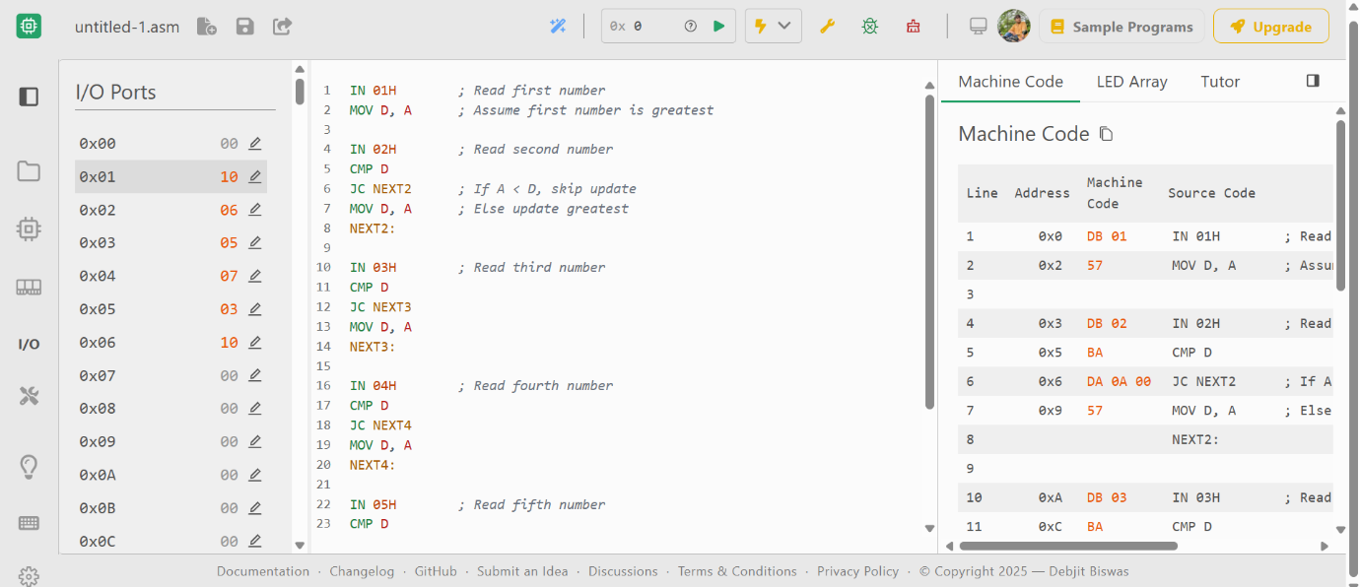

**Port Mapping**

**● Input Ports: ○ 01H → First number**

**○ 02H → Second number**

**○ 03H → Third number**

**○ 04H → Fourth number**

**○ 05H → Fifth number**

**● Output Ports (Descending Order): ○ 06H → Largest number**

**○ 07H → 2nd largest**

**○ 08H → Middle value**

**○ 09H → 2nd smallest**

**○ 0AH → Smallest number**

**Result:**

**The 8085 assembly language program was successfully executed to sort a set of numbers in descending order.**